Swagger :   
Swagger is a set of rules (in other words, a specification) **for a format describing REST APIs**. ... As a result, it can be used to share documentation among product managers, testers and developers, but can also be used by various tools to automate API-related processes.

Swagger allows you **to describe the structure of your APIs so that machines can read them**. ... Swagger does this by asking your API to return a YAML or JSON that contains a detailed description of your entire API. This file is essentially a resource listing of your API which adheres to OpenAPI Specification.

What is difference between Swagger and postman?

Postman is the only **complete API development environment**, used by nearly five million developers and more than 100,000 companies worldwide. ... Swagger UI is a dependency-free collection of HTML, Javascript, and CSS assets that dynamically generate beautiful documentation and sandbox from a Swagger-compliant API.

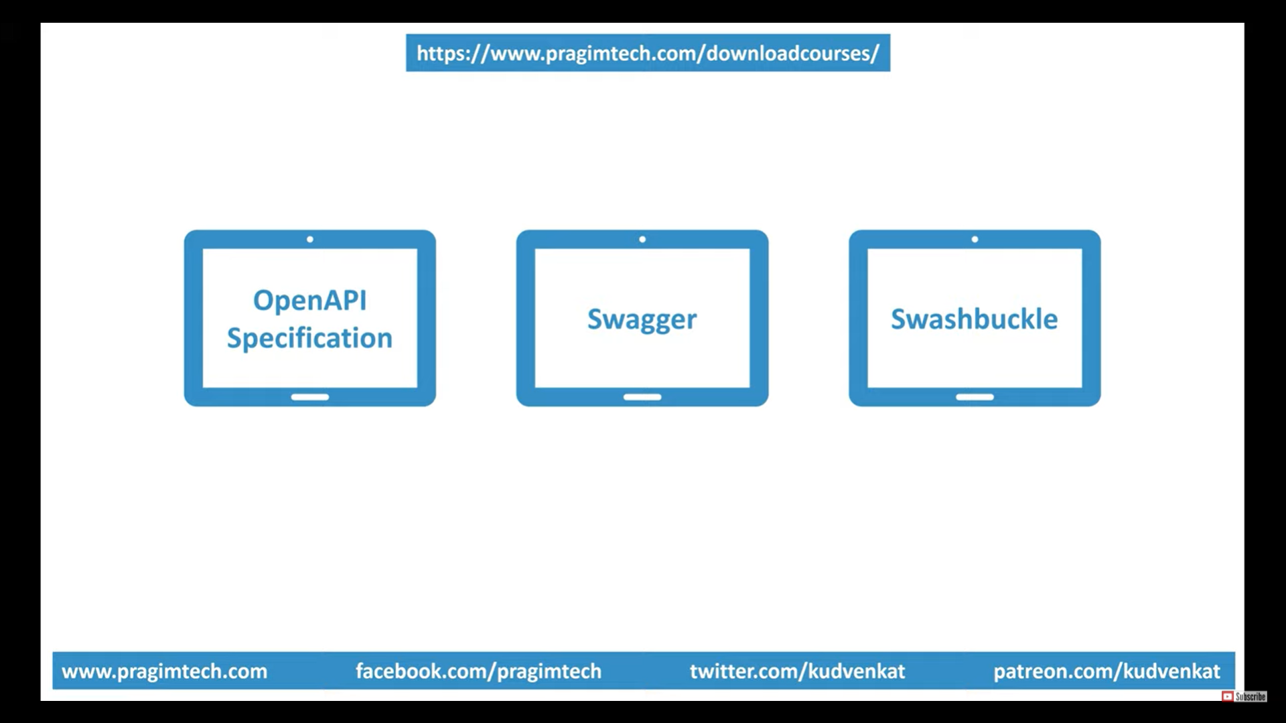

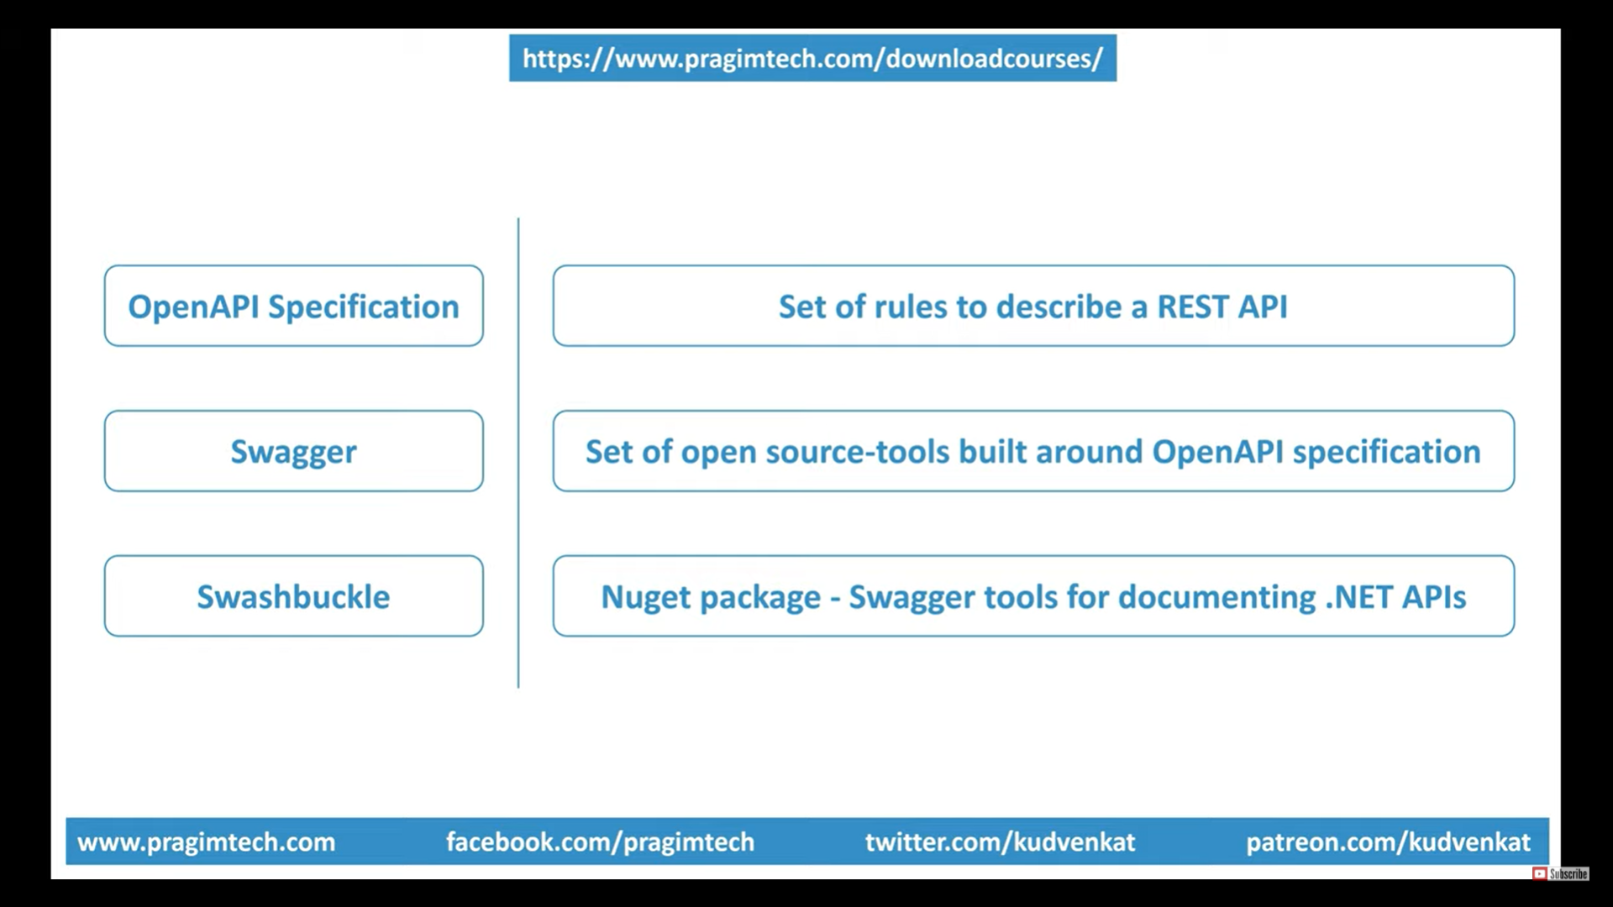

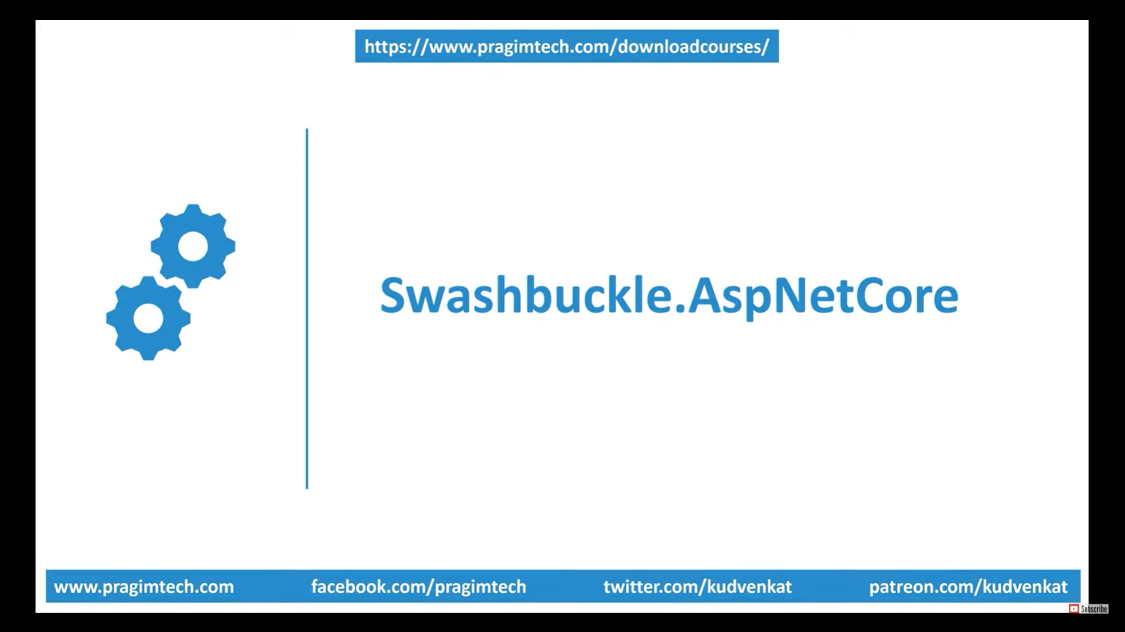

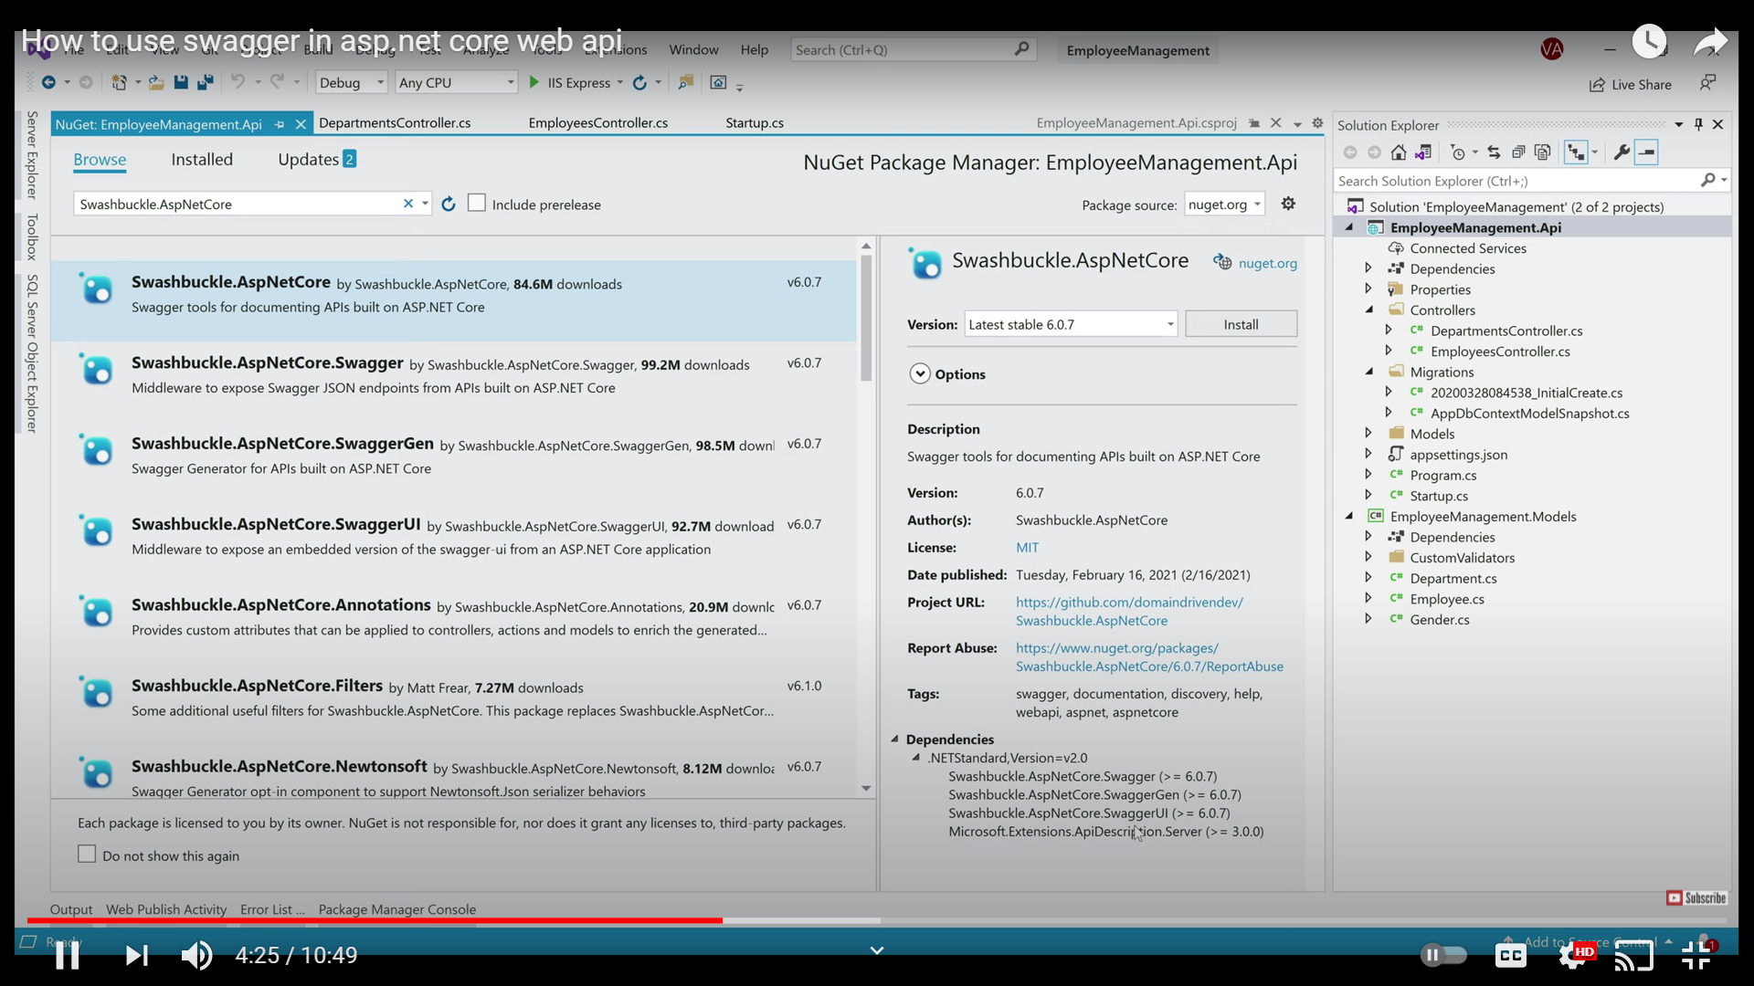

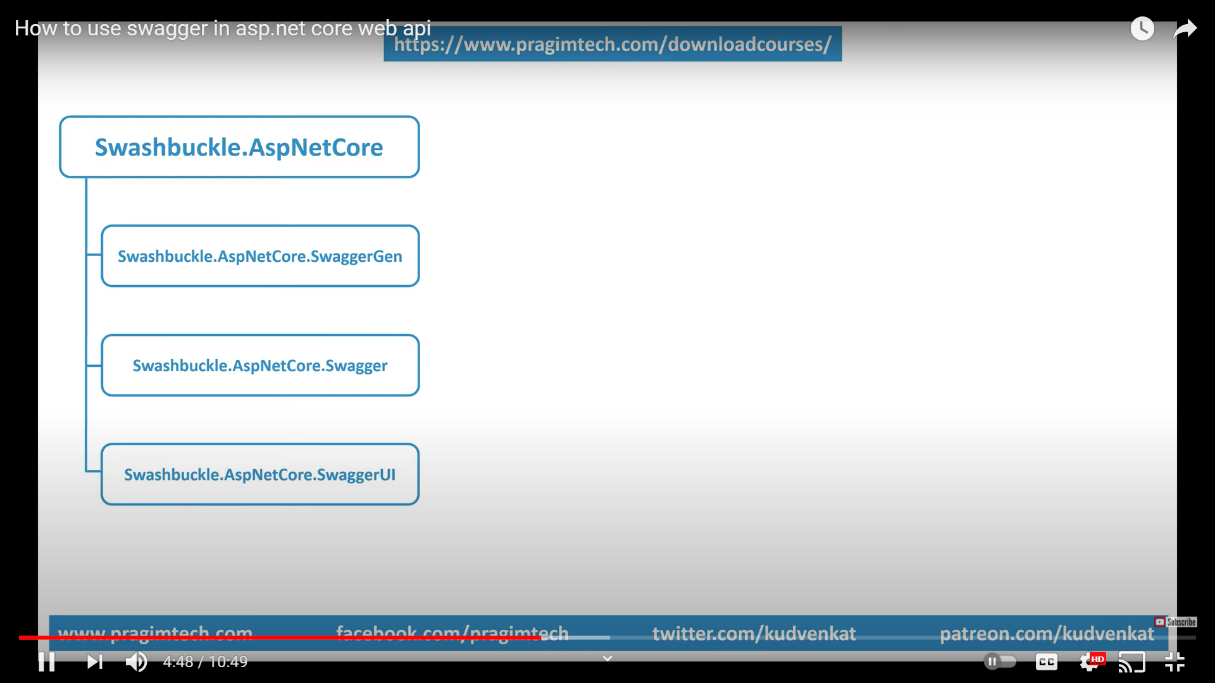

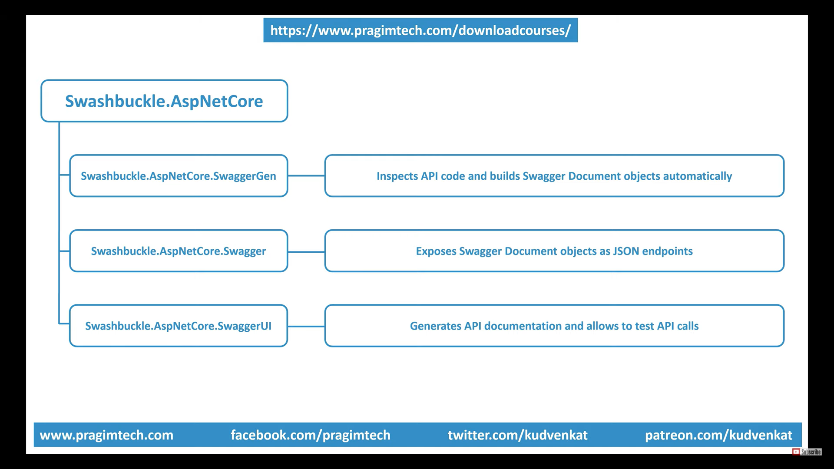

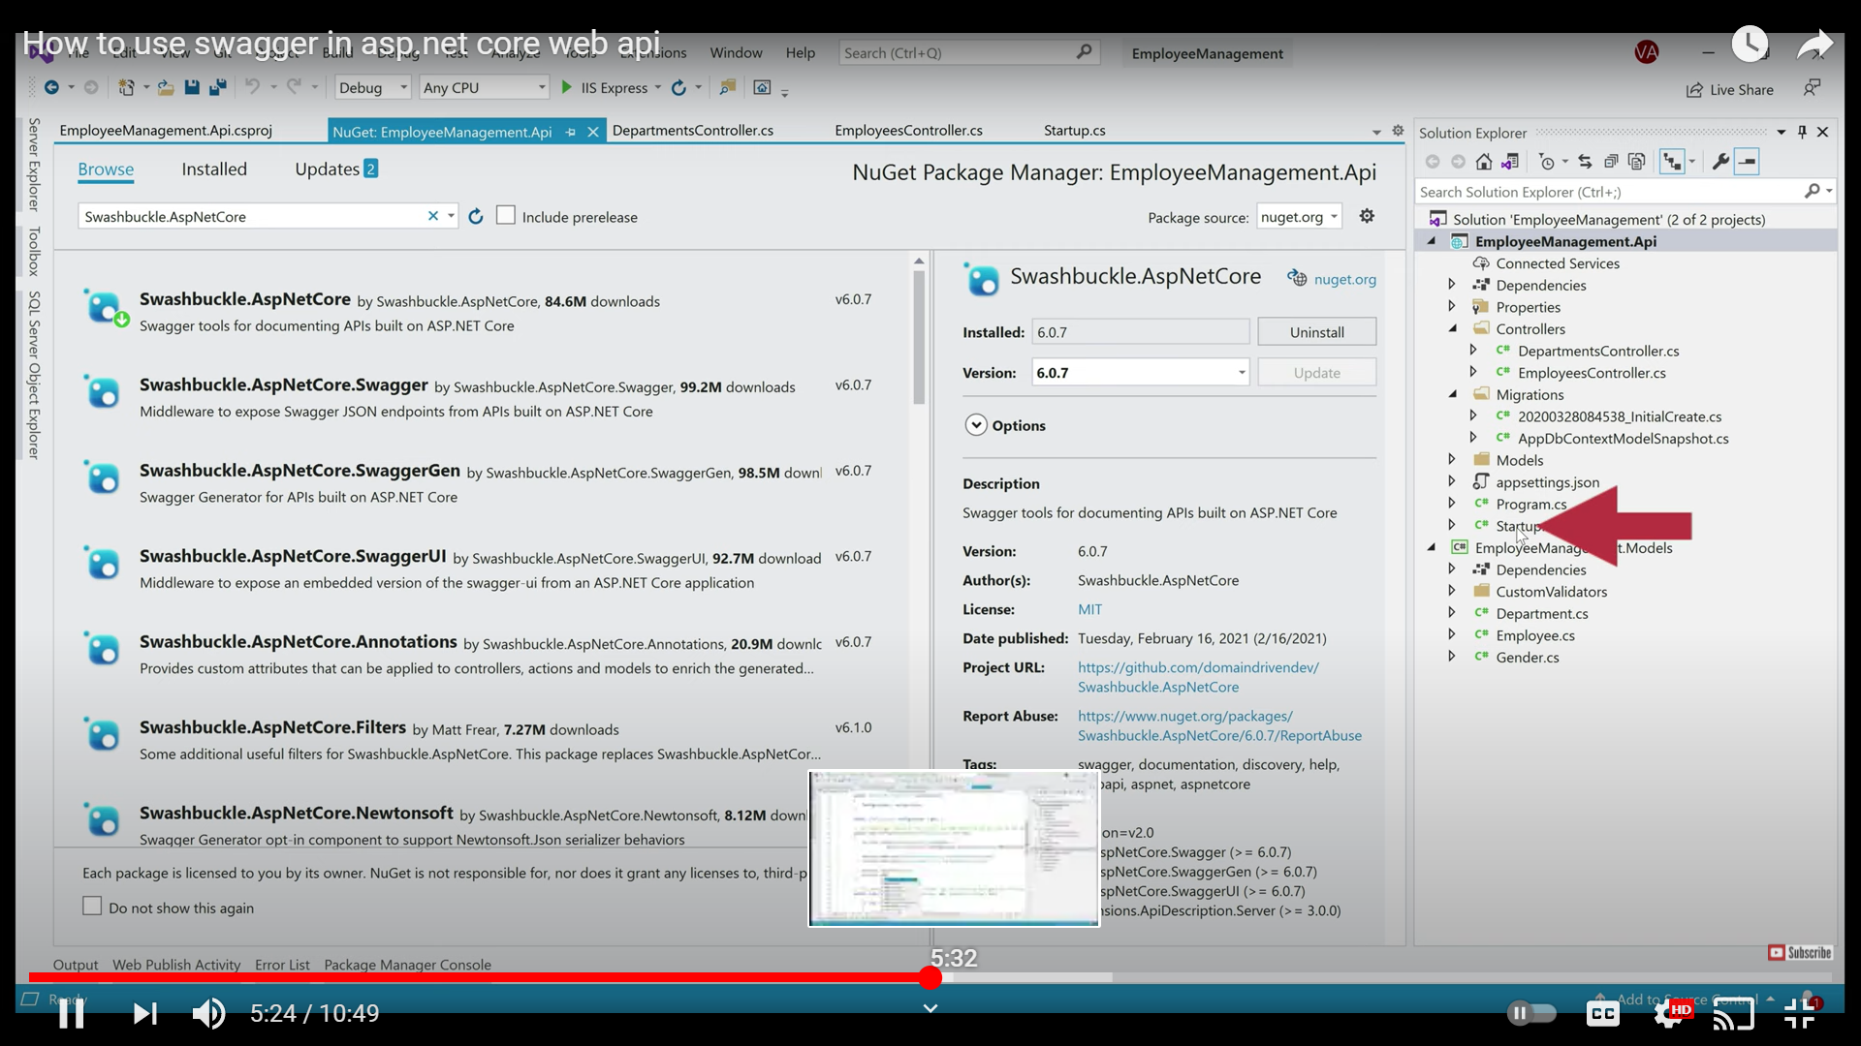

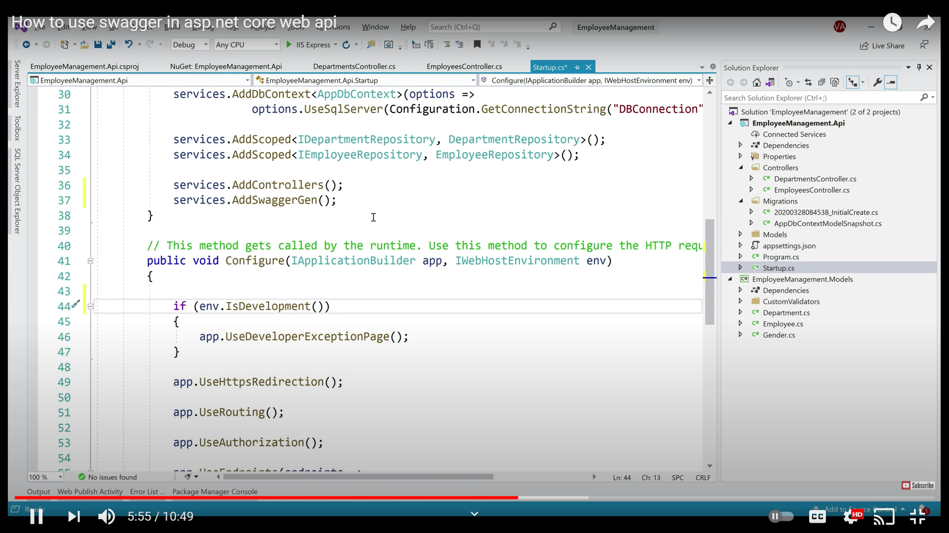

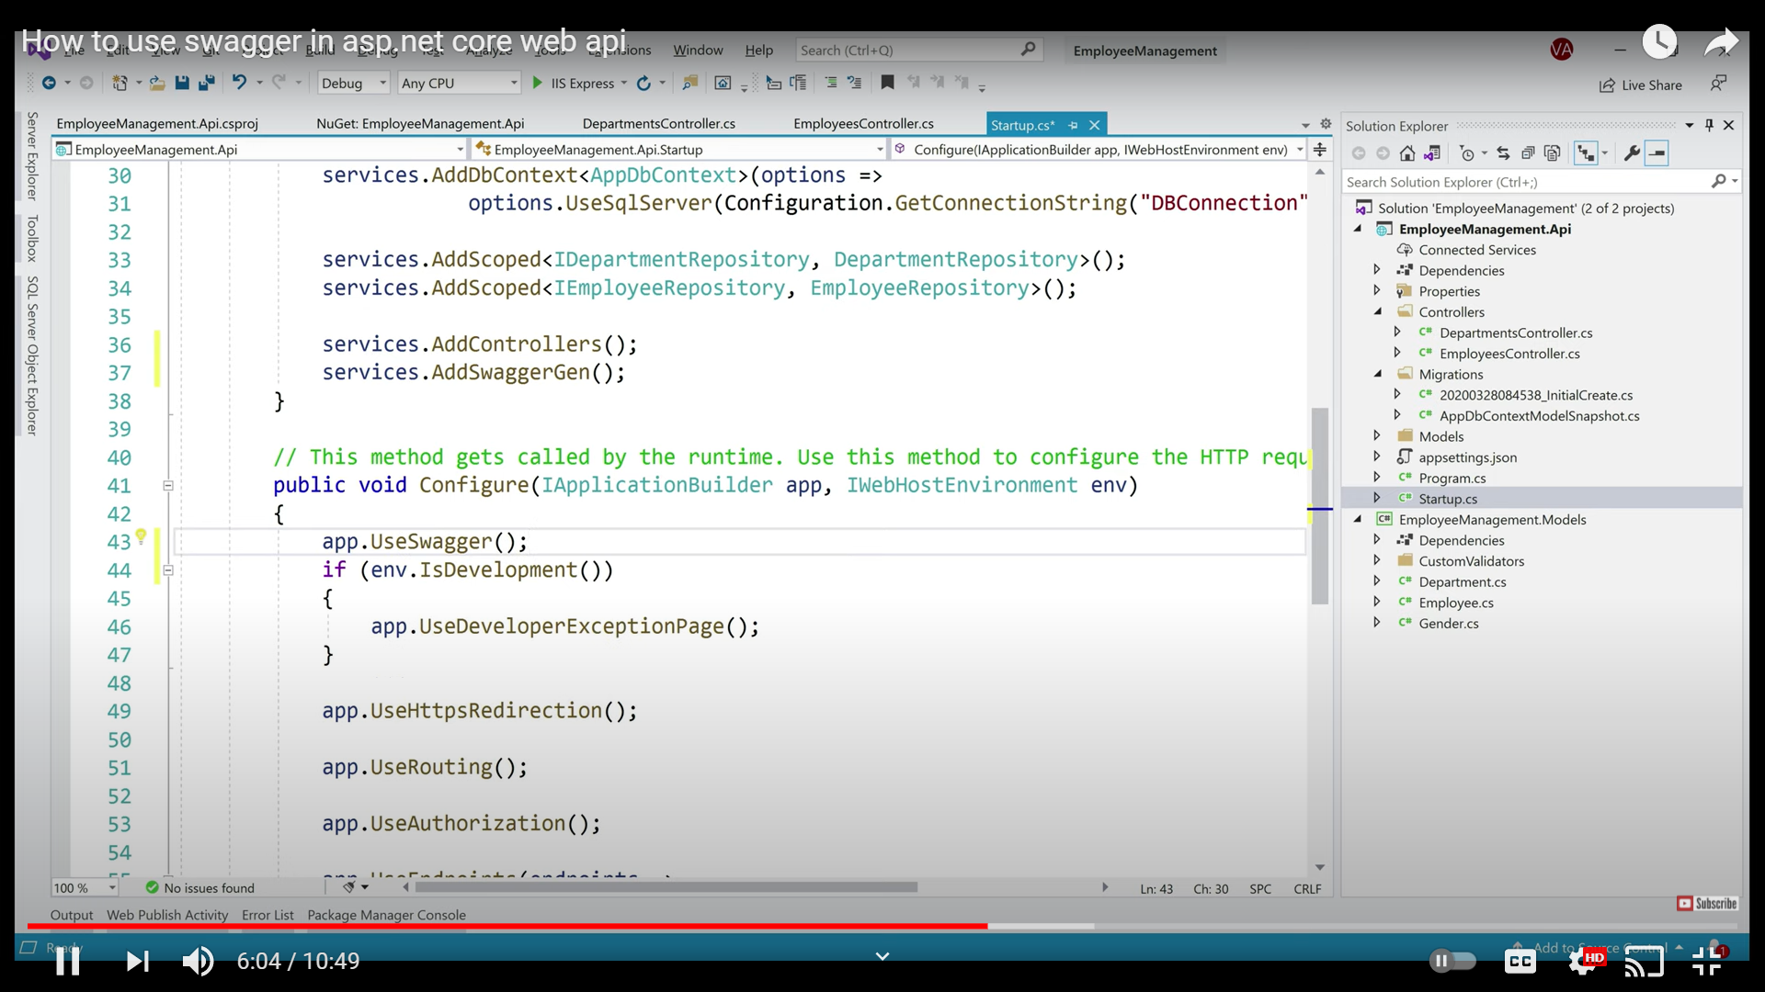

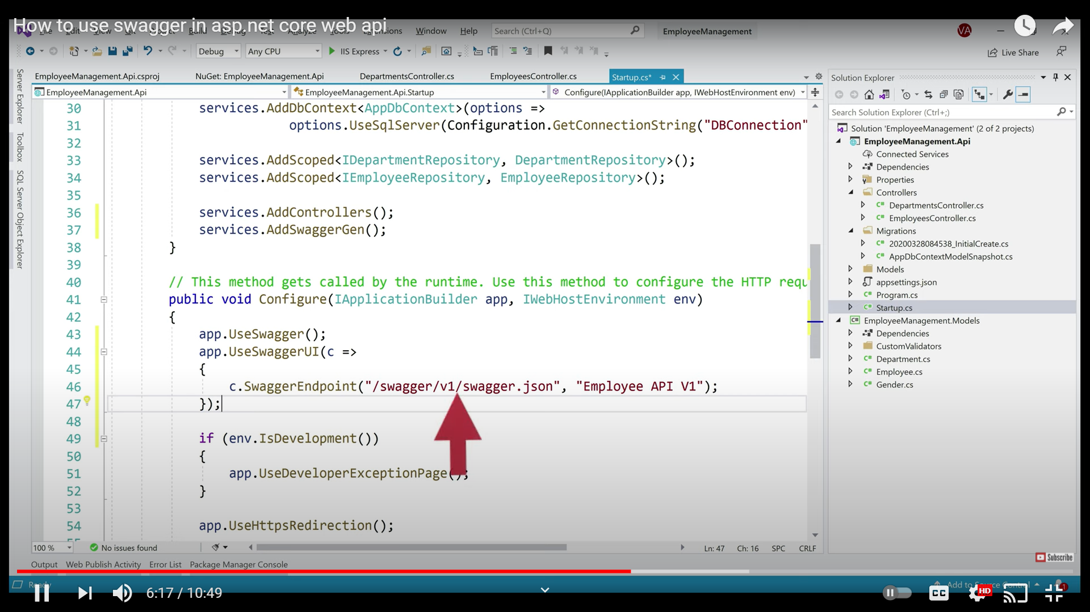

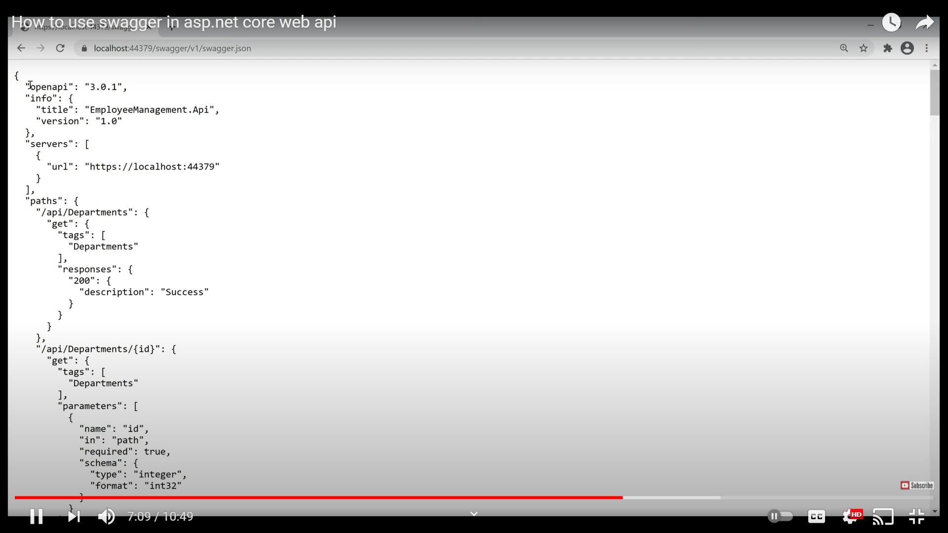

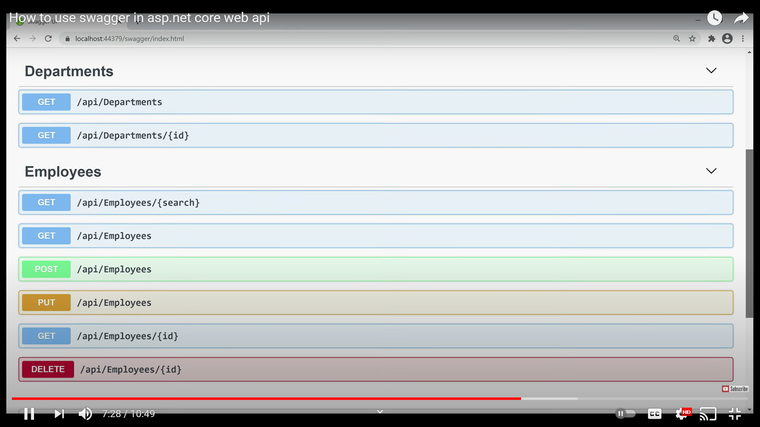

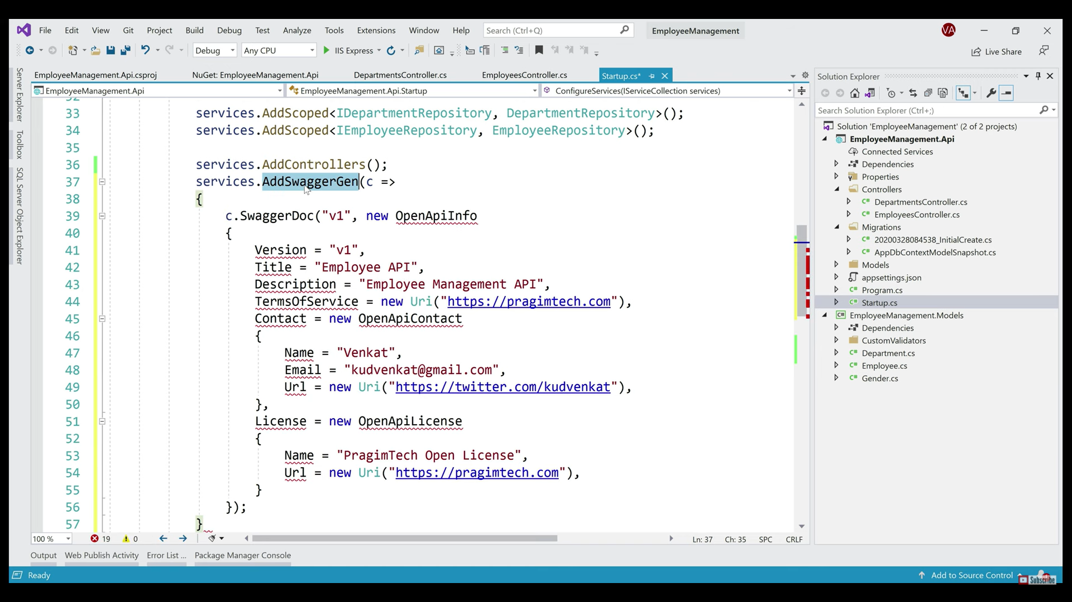

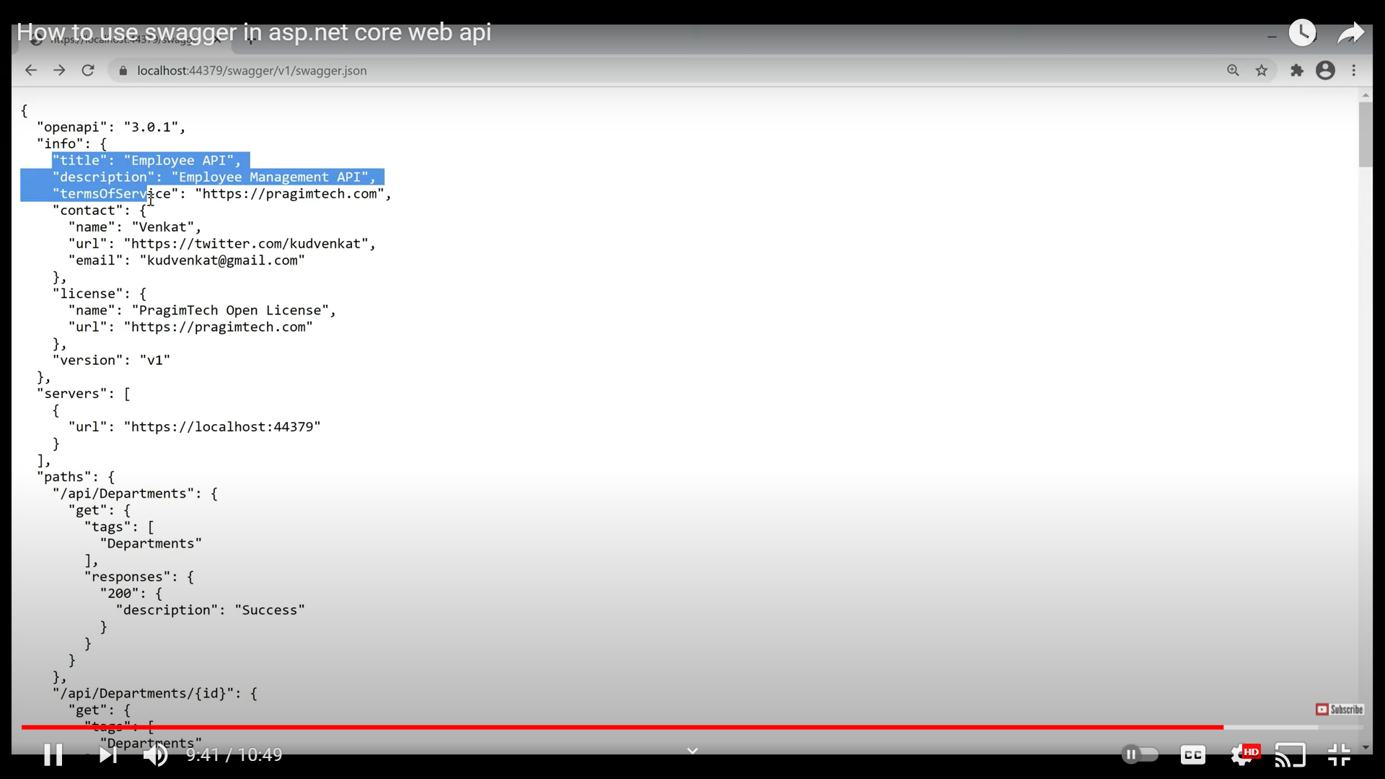

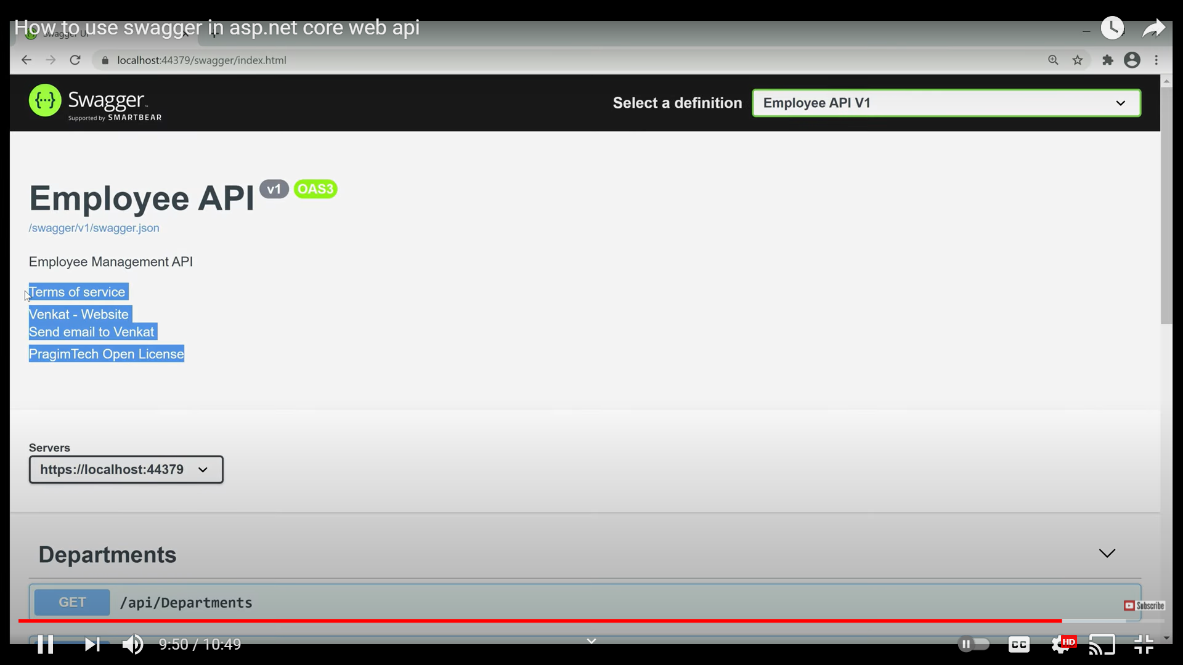

Steps :

Install-Package Swashbuckle.AspNetCore -Version 5.3.3

The **Swashbuckle.AspNetCore**metapackage contains three components:

1. **Swashbuckle.AspNetCore.Swagger:**A middleware to expose Swagger specification document as JSON endpoints from APIs
2. **Swashbuckle.AspNetCore.SwaggerGen:** A Swagger Generator that inspects the controller, routes and models to generate Swagger specification document for APIs
3. **Swashbuckle.AspNetCore.SwaggerUI:**A Swagger UI tool. It reads the Swagger JSON to build a rich UI for describing the Web API functionality. It also comes with a built-in test harnesses which lets users interact with APIs.

-------------------------------------------------------------

**Startup.cs file**

public IConfiguration Configuration { get; }

// This method gets called by the runtime. Use this method to add services to the container.

public void ConfigureServices(IServiceCollection services)

{

services.AddControllersWithViews();

**services.AddSwaggerGen(c =>**

**{**

**c.SwaggerDoc("v1", new OpenApiInfo {**

**Title = "MyTestService", Version = "v1", });**

**});**

}

**app.UseSwagger();**

**app.UseSwaggerUI(c =>**

**{**

**c.SwaggerEndpoint("/swagger/v1/swagger.json", "TestService");**

**});**

--------------------------------------------------------------------------------------

2nd option

**services.AddSwaggerGen(c =>**

**{**

**c.SwaggerDoc("v2", new OpenApiInfo**

**{**

**Title = "Swagger Demo",**

**Version = "v2",**

**Description = "TBD",**

**Contact = new OpenApiContact() { Name = "John Doe", Email = "john@xyzmail.com"},**

**License = new OpenApiLicense() { Name = "License Terms" }**

**}); });**

**app.UseSwagger();**

**app.UseSwaggerUI(c =>**

**{**

**c.SwaggerEndpoint("/swagger/v2/swagger.json", "Swagger Demo");**

**});**